**Phase 1 – GanttProject**

***(Code Smells)***

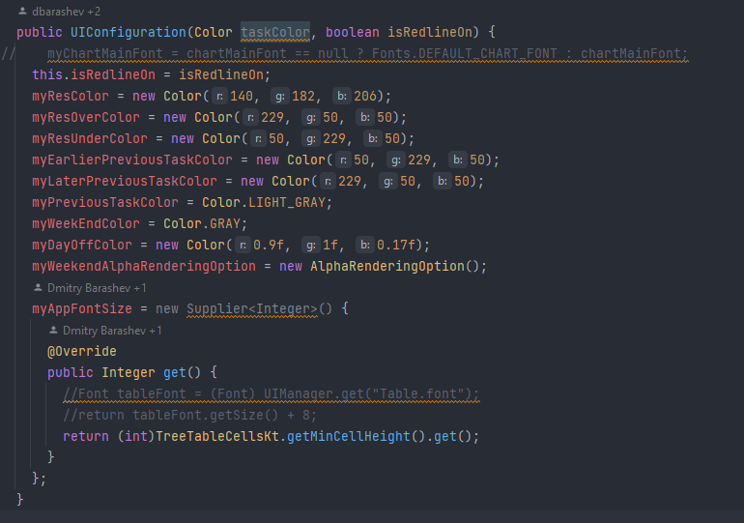**Dead Code:**

The parameter *taskColor* is never used and doesn’t alter the result of the code. Whatever color is passed, the behavior of the code will be the same.

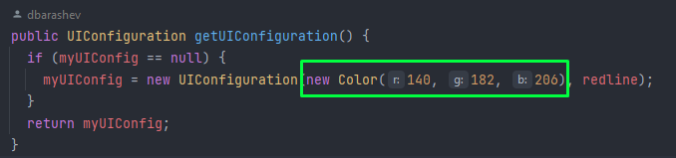

In this example, the highlighted parameter will never be used.

**Suggestion:** Remove the parameter from the method so it’s less confusing and doesn’t make the user need to input useless information.